Felipe Saadi, Jonas Sales e Raissa Sabino

AtendeAI: A Multimodal Artificial Intelligence Platform for Citizen Service

SÃO PAULO
2025

Felipe Saadi, Jonas Sales e Raissa Sabino

AtendeAI: A Multimodal Artificial Intelligence Platform for Citizen Service

Final Course Project submitted to the Institute of Technology and Leadership (INTELI) as a partial requirement to obtain the Bachelor’s degree in Software Engineering and Computer Science.
Advisor: Prof. Ana Cristina dos Santos

SÃO PAULO
2025

Cataloging in Publication
Library and Documentation Service
Institute of Technology and Leadership (INTELI)
Data entered by the author.
(Cataloging record with international cataloging data, according to NBR 14724. The record will be completed later, after approval and before the final version is deposited. The completion of the cataloging record is the responsibility of the institution's library.)

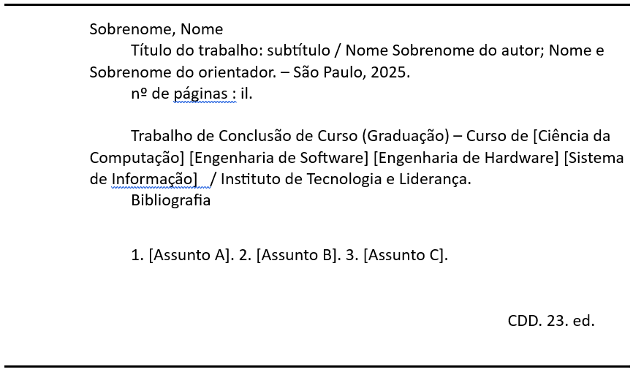

Acknowledgments
First, we would like to thank our teammates and project participants for their tireless partnership, the technical discussions that enriched our solution, and the mutual support during every sprint and challenge overcome throughout this journey.
To our family, who served as the fundamental foundation for us to get here. Thank you for your patience during my absences, for your constant encouragement, and for believing in our potential even on the most exhausting days.
To our friends, who were present with words of encouragement and moments of relaxation, which were essential to maintaining the balance and motivation necessary to complete this work. Sales gives special thanks to Gustavo Monteiro, for being a major friend and believing in his future.
Finally, we would like to thank all the professionals and mentors who, directly or indirectly, contributed their knowledge to the realization of this project.

The true measure of technology is not innovation itself, but the positive impact it creates in people’s everyday lives.

Resumo

SAADI, Felipe; SALES, Jonas; SABINO, Raissa. AtendeAI: Uma Plataforma de Inteligência Artificial Multimodal para Atendimento ao Cidadão. 2025. 25 Páginas. Trabalho de Conclusão de Curso Bacharelado em Engenharia de Software e Ciência da Computação – Instituto de Tecnologia e Liderança, São Paulo, 2025.
Este trabalho apresenta o desenvolvimento do AtendeAI, uma plataforma digital de atendimento ao cidadão baseada em inteligência artificial, desenvolvida em parceria com a PRODAM e a IBM. O projeto tem como objetivo modernizar e simplificar o processo de solicitação de serviços públicos, substituindo fluxos burocráticos baseados em formulários por uma interface conversacional acessível, multimodal e escalável. A solução integra tecnologias de processamento de linguagem natural, visão computacional, reconhecimento de fala (speech-to-text) e síntese de fala (text-to-speech), utilizando serviços da IBM Cloud, como o Watson Assistant e o watsonx.ai.
Foi adotada uma metodologia iterativa e incremental baseada no Scrum, estruturada em três módulos: definição arquitetural e protótipo navegável; desenvolvimento do agente inteligente com integração backend e frontend; e incorporação de funcionalidades multimodais e análise de vieses em inteligência artificial. Os resultados indicam que o AtendeAI possui potencial para reduzir a complexidade do atendimento, aumentar a acessibilidade digital e melhorar a eficiência operacional no setor público, mantendo custos operacionais sustentáveis e escaláveis em nuvem.

Palavras-Chave: inteligência artificial; serviços públicos digitais; chatbot; acessibilidade; computação em nuvem.

ABSTRACT

SAADI, Felipe; SALES, Jonas; SABINO, Raissa. AtendeAI: A Multimodal Artificial Intelligence Platform for Citizen Service. 2025. 25 pages. f. Final Course Project (Bachelor) – Course Computer Science and Software Engineering, Institute of Technology and Leadership, São Paulo, 2025.
This work presents the development of AtendeAI, a digital citizen service platform based on artificial intelligence, developed in partnership with PRODAM and IBM. The project aims to modernize and simplify the process of requesting public services by replacing bureaucratic, form-based workflows with an accessible, multimodal, and scalable conversational interface. The solution integrates natural language processing, computer vision, speech-to-text, and text-to-speech technologies, using IBM Cloud services such as Watson Assistant and watsonx.ai. An iterative and incremental methodology based on Scrum was adopted, structured into three modules: architectural definition and navigable prototype, intelligent agent development with backend and frontend integration, and the incorporation of multimodal features and artificial intelligence bias analysis. The results indicate that AtendeAI has the potential to reduce service complexity, increase digital accessibility, and improve operational efficiency in the public sector while maintaining sustainable and scalable cloud-based operational costs.

Keywords: artificial intelligence; digital public services; chatbot; accessibility; cloud computing.

List of Illustrations

Figure 1 – Comparative Benchmark…………………................................................. 13 Figure 2 – BPMN........................................................................................................14 Figure 3 – C4 Model Context......................................................................................15 Figure 4 – Architecture ..............................................................................................18
Figure 5 – Monthly Operational Costs Bar Graph .....................................................22

List of Abbreviations and Acronyms
AI: Artificial Intelligence
API: Application Programming Interface
BPMN: Business Process Model and Notation
C4: Context, Containers, Components, and Code (Architectural Model)
eMAG: Electronic Government Accessibility Model
ICT: Information and Communication Technology
JWT: JSON Web Token
LLM: Large Language Model
MVP: Minimum Viable Product
NLP: Natural Language Processing
PRODAM: São Paulo Municipal Information and Communication Technology Company
REST: Representational State Transfer
STT: Speech-to-Text
TTS: Text-to-Speech
WCAG: Web Content Accessibility Guidelines

Summary

1 Introduction 9
1.1 Partner Company Context 9
1.2 Problem Definition (Corporate Pain Point) 10
1.3 Proposed Solution and Expected Contribution 10
1.4 Business Objectives 11
1.5 Structure of the thesis/dissertation 11
2 Solution Development 12
2.1 Applied Rationale 12
2.1.1 Business Area Rationale 13
2.1.2 Technological rationale for the solution 14
2.1.3 Fundamentals of Management and Development Methods 15
2.2 Specification and Development 16
2.2.1 Requirements and Specifications 16
2.2.2 Architecture and Technology 17
2.2.3 Development and Implementation (MVP) 18
2.2.4 Testing and Technical Evaluation 19
2.3 Assessment of Impact and Contribution to the Business 20
2.3.1 Defining Corporate Success Metrics 20
2.3.2 Results and Impact Analysis 21
2.3.3 Cost-Benefit Analysis 21
2.3.4 Critical Success Factors and Lessons Learned 23
3 Conclusion 23
References 24

Introduction
Digital transformation in the public sector has become a strategic factor for expanding citizens’ access to essential services, reducing operational costs, and increasing administrative efficiency. In this context, PRODAM, the technology company of the São Paulo City Hall, faces the challenge of modernizing citizen service platforms that are historically marked by bureaucratic processes, multiple steps, and low usability.
The main problem identified lies in the difficulty citizens face when registering requests for urban services, such as maintenance, public cleaning, or emergency incidents. Traditional systems require manual service categorization and extensive form completion, which leads to errors, rework, and user frustration. Qualitative evaluations of existing platforms, such as SP156, highlight usability issues, excessive steps, and limited accessibility.
As a solution, AtendeAI is proposed: a computational platform based on artificial intelligence that allows citizens to submit service requests through natural conversation using text, voice, or images. The project’s objective is to reduce service complexity and improve user experience by promoting accessibility, automation, and transparency in request tracking.

  - Partner Company Context:

PRODAM SP (São Paulo Municipal Information and Communication Technology Company) is a mixed-economy company founded in 1971, whose mission is to act as a strategic provider and integrator of ICT solutions for public administration, with a strong focus on citizens. Over more than five decades, PRODAM has played a fundamental role in the digital modernization of São Paulo’s municipal administration, developing technological solutions aimed at increasing efficiency, transparency, and service quality.
In the context of large urban centers such as São Paulo, citizen service management represents a critical challenge. The increasing volume of requests, complaints, and suggestions demands digital solutions capable of centralizing information, integrating multiple departments, and ensuring accessible and efficient communication between the population and public institutions. In this scenario, technology becomes a key enabler for improving public service delivery and strengthening citizens’ trust in government institutions.

  - Problem Definition (Corporate Pain Point):

The management of citizen service requests across municipal departments is currently fragmented and inefficient. Each department often operates its own service channels, resulting in a confusing experience for citizens and difficulties in tracking and resolving requests. The lack of technological integration between systems prevents data sharing and limits the ability to perform consolidated analyses for decision-making.
Although the SP156 system represents an important step toward centralization, it still presents limitations related to usability, accessibility, and the use of advanced technologies. The absence of intelligent automation leads to manual categorization of requests, delays in service delivery, limited transparency regarding request status, and increased operational workload for public servants. From PRODAM’s institutional perspective, the limited control over the evolution of strategic systems such as SP156 also poses risks related to service continuity and strategic positioning.

  - Proposed Solution and Expected Contribution:

As discussed in Section 1, the main objective of this work is the development of an artificial intelligence–based platform designed to centralize, automate, and optimize citizen service management for municipal departments.
Specific objectives include improving the efficiency and accuracy of request routing, reducing response times, increasing transparency in service tracking, and enhancing accessibility through multimodal interaction channels such as text, voice, and images. Additionally, the project aims to strengthen PRODAM’s strategic role by proposing a scalable and intelligent solution aligned with the digital transformation goals of public administration.

  - Business Objectives:

The development of AtendeAI is justified by the growing demand for more efficient, accessible, and intelligent public services. Current citizen service models generate operational inefficiencies, low transparency, and user dissatisfaction. By incorporating artificial intelligence technologies such as natural language processing, image recognition, and intelligent prioritization, AtendeAI addresses both citizen-facing and institutional challenges.
For PRODAM, the project represents an opportunity to expand its product portfolio, strengthen its strategic positioning, and gain greater control over critical public service systems. For citizens, the solution promises faster responses, simplified interaction, and clearer visibility into the status of their requests. The collaboration with Inteli further justifies the project by combining academic innovation with real-world public sector needs.

  - Structure of the thesis/dissertation:

This work is structured into distinct chapters. Chapter 1 introduces the context, problem statement, objectives, and justification of the project. Chapter 2 presents the development of the AtendeAI solution, including its applied rationale, specifications, and architectural aspects. also discussing the impact and contributions of the proposed system to public service management. Finally, Chapter 3 concludes the work and outlines directions for future improvements.

Solution Development

Applied Rationale
The strategic positioning of this project lies within the digital public services sector, aiming to transform how the population interacts with government services through efficiency and scalability. Benchmarking analysis against established platforms like SP156, Conecta Recife, and Gov.br reveals that while these tools provide broad coverage, they often lack advanced AI-driven automation and intuitive user experiences.
To bridge these gaps, AtendeAI leverages a robust foundation of Natural Language Processing (NLP), microservices, and cloud-native architectures. The integration of IBM Watson Assistant and watsonx.ai was a deliberate choice, driven by their native support for generative AI and strict compliance with the security standards required by PRODAM’s corporate infrastructure.
The project’s execution was governed by the Scrum framework, ensuring continuous evolution through biweekly sprints. This iterative approach fostered frequent alignment with stakeholders and allowed for rapid adjustments based on partner feedback
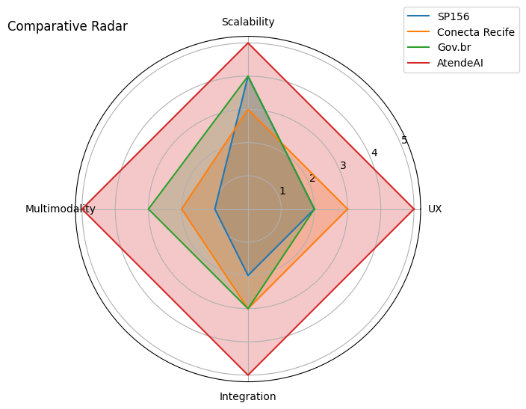
Figure 1 - Comparative Benchmark

    - Business Area Rationale:

By aligning with PRODAM’s mission as a citizen-centric ICT integrator, AtendeAI serves as a strategic response to the institutional challenges of fragmented service channels and limited control over legacy systems. The proposal of a centralized, intelligent platform not only expands PRODAM’s product portfolio but also enhances its strategic influence within the municipal administration. Beyond operational gains, the solution empowers governance through data transparency and consolidated analytics, facilitating high-level decision-making

    - Technological rationale for the solution:
The architectural blueprint of AtendeAI prioritizes scalability and high availability, employing a microservices-based model where services are fully containerized for cloud deployment. By combining IBM Watson’s ecosystem with Large Language Models (LLMs), the platform enables sophisticated multimodal interactions—processing text, audio, and images to automate request classification and prioritization.
Adhering to industry standards, the system design utilizes BPMN for process mapping and the C4 model for architectural visualization. Security and performance are reinforced by a modern stack comprising API Gateways, OAuth2/JWT authentication, and efficient caching mechanisms, ensuring the platform integrates seamlessly into the partner company's existing IT ecosystem.
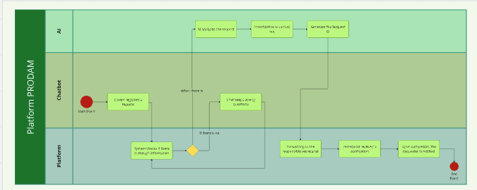
Figure 2 - BPMN
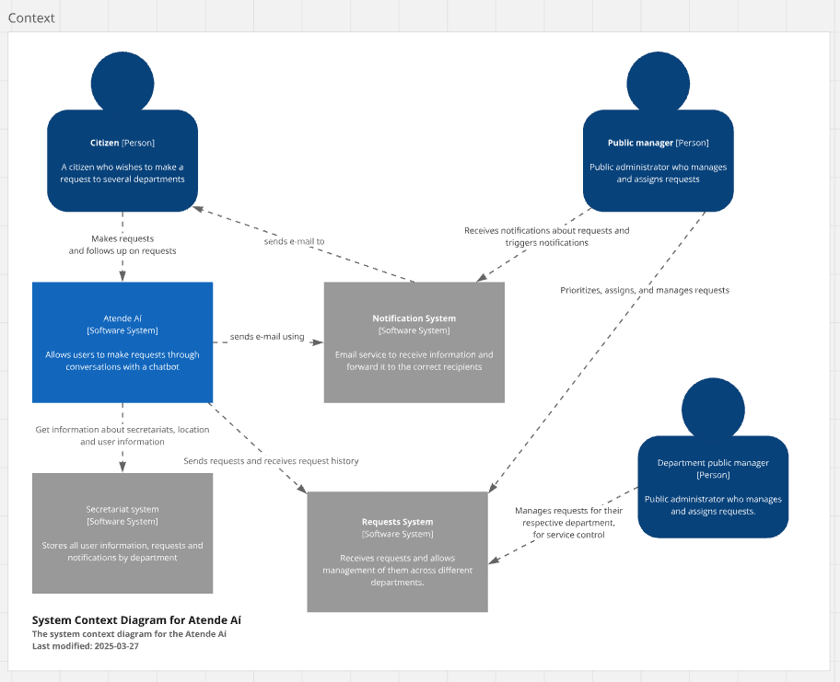
Figure 3 - C4 Model Context

    - Fundamentals of Management and Development Methods:
The development of AtendeAI follows agile methodologies, primarily Scrum, as defined in the Inteli project plan. The project is structured into modules and biweekly sprints, enabling incremental delivery, continuous validation with the partner, and frequent incorporation of feedback. Sprint rituals such as planning, review, and retrospectives ensure transparency, risk mitigation, and continuous improvement throughout the development lifecycle. This methodological approach allows flexibility in managing scope changes while maintaining alignment with project objectives, deadlines, and institutional constraints.

  - Specification and Development :
The technical specification of AtendeAI was derived from a comprehensive analysis of functional and non-functional requirements, ensuring strict alignment with the standards and operational needs of the partner company

    - Requirements and Specifications:
To support the complete lifecycle of citizen service requests, the platform’s functional requirements enable users to interact via a conversational chatbot, attach multimodal files (images and audio), and receive unique tracking identifiers. Behind the interface, the system leverages artificial intelligence to automatically categorize and prioritize these requests, streamlining the routing process to the appropriate municipal agencies.
For administrative and authorized users, the platform offers a management suite that includes:
- Request Lifecycle Management: Tools for status updates, inter-organization forwarding, and automated notifications via email or system messages.
- Data Privacy: Built-in features for citizen data anonymization to comply with security standards.
- Analytical Dashboards: Consolidated reports on service demand, response times, and trends to support data-driven decision-making.
On a technical level, the non-functional requirements prioritize high availability and digital inclusion, adhering to WCAG and eMAG accessibility standards. The infrastructure is built on a microservices-based architecture to handle high request volumes while maintaining secure data handling and compatibility with PRODAM’s existing IT ecosystem.

    - Architecture and Technology:

The AtendeAI solution adopts a cloud-native, microservices-based architecture, designed to support scalability, interoperability, and ease of integration with public-sector systems.
The architectural design follows:
- C4 Model (Context, Containers, Components) for structural clarity
- BPMN for modeling citizen service workflows
The system is composed of:
- Frontend layer: Responsive and accessible interface, optimized for mobile usage and compliant with accessibility guidelines.
- Backend layer: Implemented with Node.js and TypeScript, exposing RESTful APIs and centralizing business logic through an API Gateway.
- Data layer: MongoDB for conversational data and service requests, with cloud object storage for multimedia files.
- AI services layer: IBM Watson Assistant and watsonx.ai, responsible for natural language understanding, conversational orchestration, multimodal processing (text, audio, image), and automated request classification.
The final architecture is cloud-agnostic, allowing deployment on IBM Cloud or other cloud services such as AWS, Azure, and others, and supports infrastructure automation and future scalability. According to PRODAM’s goals and current technology, this implementation aligns with their digital transformation strategy, since IBM is not their cloud service provider.
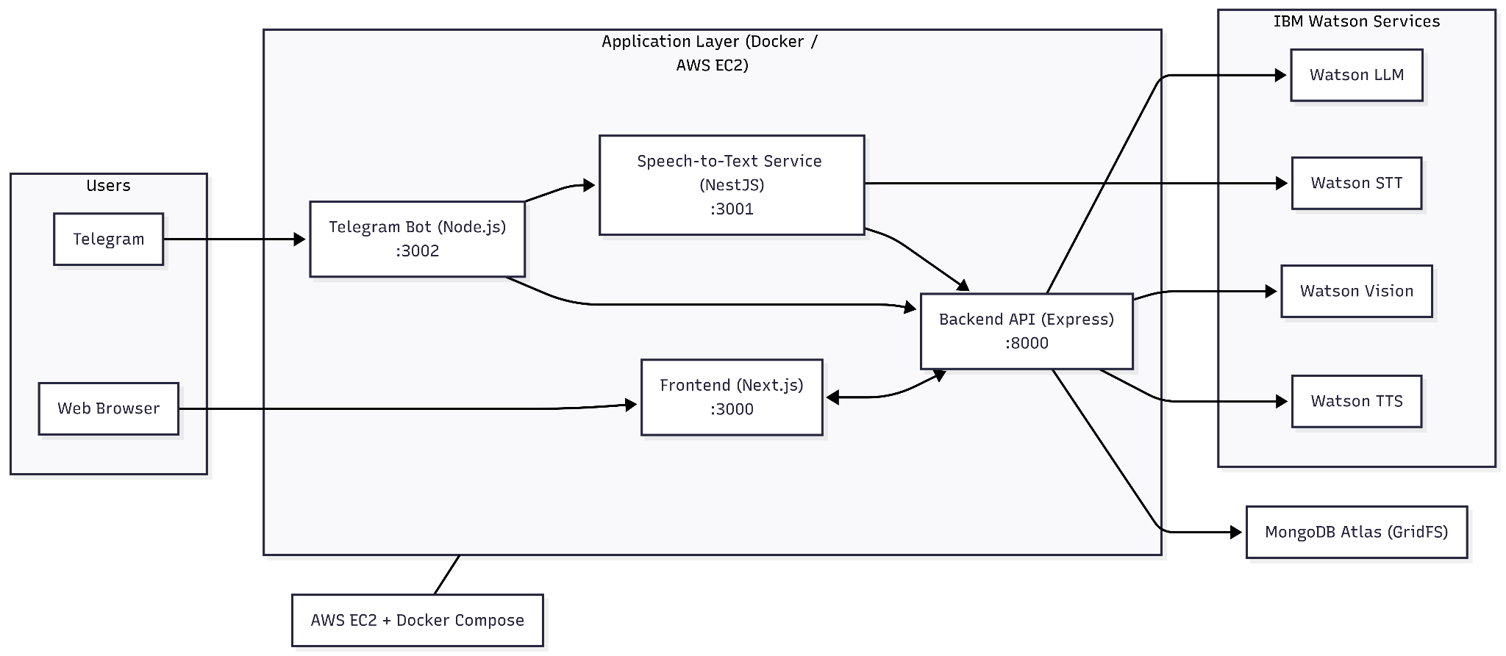
Figure 4 - Architecture
    - Development and Implementation (MVP):

The construction of the AtendeAI MVP followed an iterative and incremental approach, ensuring that technical development remained aligned with the strategic needs of PRODAM and the technological capabilities of IBM.
Development Methodology The project was managed using the Scrum framework, organized into biweekly sprints as defined in the Inteli project plan. This methodology allowed for:
- Incremental Deliveries: Each sprint resulted in a functional increment of the platform, starting from the architectural setup to the integration of multimodal AI features.
- Agile Rituals: Planning, reviews, and retrospectives were conducted to mitigate risks, incorporate partner feedback, and ensure continuous improvement of the solution.
- Collaborative Validation: Frequent demonstrations to PRODAM stakeholders ensured that the evolving product met the expectations for a modern citizen service interface.
Integration and Pilot Deployment Process The implementation phase focused on creating a seamless integration between the custom-built modules and the IBM Cloud ecosystem. The deployment process was structured as follows:
- Containerization: All backend and frontend services were fully containerized, allowing for a consistent environment from development to testing.
- Infrastructure Integration: The solution was deployed using managed cloud services and an API Gateway to facilitate communication with IBM Watson Assistant and the LLMs provided by watsonx.ai.
- Pilot Execution: For the MVP stage, a pilot deployment was established in a controlled environment to validate the integration with existing municipal data standards. This setup ensures high availability and security, following OAuth2 and JWT standards, while allowing for future scalability within PRODAM’s IT infrastructure.

    - Testing and Technical Evaluation:
Testing activities focused on validating the functional behavior and integration reliability of the AtendeAI MVP. Given the academic scope of the project, testing was oriented toward correctness rather than production-scale performance.
The evaluation included:
- Functional testing of core features:
  - Conversational request creation
  - Multimedia submission (text, audio, images)
  - Request tracking and status updates
- Integration testing between frontend, backend, database, and AI services (Watson Assistant, STT, TTS, and image analysis).
- End-to-end testing based on defined personas, simulating realistic citizen and analyst workflows.
Advanced testing strategies such as load, stress, and security testing were out of scope for current project academic constraints, but the system architecture includes logging, monitoring, and modular components that support these evaluations in future deployments.

Assessment of Impact and Contribution to the Business
The project’s main success indicators are related to reducing service complexity, improving user experience, and potentially decreasing request processing time. Although developed in an academic environment, simulations and comparative analyses indicate significant qualitative improvements over traditional platforms.
Operational cost analysis shows that AtendeAI is financially viable, with an estimated monthly cost compatible with scalable cloud-based solutions. Furthermore, automation enabled by the intelligent agent tends to reduce rework and increase operational efficiency for service teams.
Critical success factors include integration with consolidated IBM services, the adoption of a modular architecture, and attention to artificial intelligence bias issues, particularly in computer vision applications.

    - Defining Corporate Success Metrics:
To assess the effectiveness of the AtendeAI platform, a set of corporate success metrics was defined based on the baseline limitations of traditional public service systems and the project’s strategic objectives.
The proposed metrics include:
- Average request handling time
- Request classification accuracy
- Automation rate of service requests
- User satisfaction level
- Operational cost per request
These indicators provide PRODAM with a structured framework to evaluate efficiency gains, service quality improvements, and cost optimization in future production environments.
It is important to note that no data was collected throughout the project’s development span, since the success metrics were validated by PRODAM on a 2-week Sprint development cycle.

    - Results and Impact Analysis:
The evaluation of AtendeAI compares its expected outcomes against baseline characteristics of conventional public service platforms, such as manual request categorization, limited accessibility, and fragmented workflows.
Quantitative Analysis (Simulated):
- AI-driven classification and automation indicate a potential reduction of 10–20% in manual request handling effort.
- The estimated operational cost of the MVP is approximately R$ 322.75 per month, enabled by cloud-based infrastructure.
Qualitative Analysis:
- Improved agility through automated prioritization and reduced rework.
- Increased citizen satisfaction due to conversational interaction and diversified input.
- Enhanced decision-making for public servants through better-structured and more complete requests.
These results demonstrate the platform’s potential to improve efficiency and service quality in public administration contexts.

    - Cost-Benefit Analysis:

The cost-benefit analysis considers the balance between operational expenses and expected efficiency gains. The estimated monthly operational cost of R$ 322.75 covers cloud services and AI processing required to support the MVP.
Key benefits include:
- Reduced manual processing and reclassification of requests
- Faster service response times
- Improved data quality and transparency
- Higher citizen engagement and satisfaction
Development costs were not monetarily quantified, as the scope of this academic project focused on validating technical feasibility, architectural soundness, and operational viability rather than estimating full production development efforts. In a real deployment scenario, development and maintenance activities would be absorbed by PRODAM’s internal teams, making such costs highly context-dependent. Therefore, the cost-benefit analysis prioritizes operational expenses, which are more directly measurable and relevant for assessing scalability and efficiency gains, particularly for large municipalities.

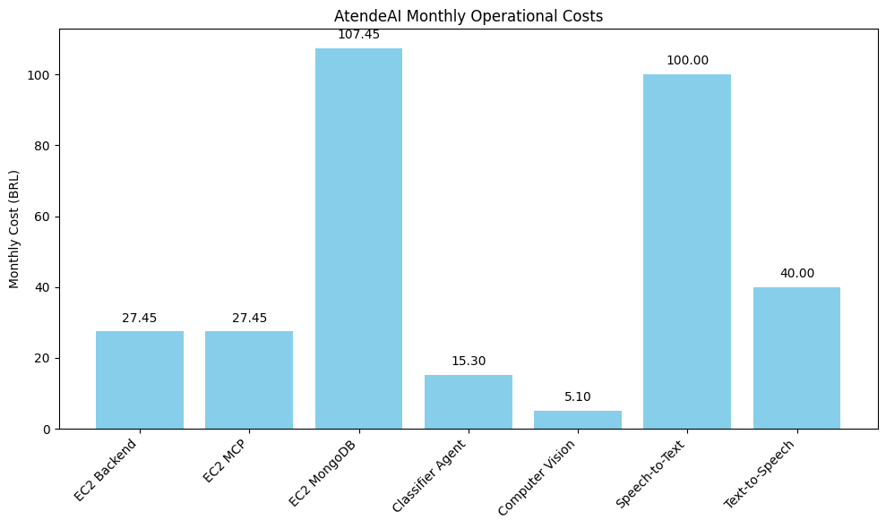
Figure 5 - Monthly Operational Costs Bar Graph

    - Critical Success Factors and Lessons Learned:

Several critical success factors were identified during the development of AtendeAI:
- Adoption of a modular and scalable architecture
- Integration of AI-driven automation for request classification
- Focus on accessibility and multimodal interaction
Key lessons learned include:
- The importance of high-quality data for AI effectiveness
- Awareness of bias and fairness in automated systems
- The value of iterative, agile development for managing complexity and refinement
These factors and lessons provide a solid foundation for future enhancements and real-world deployment of the platform.

Conclusion

This work presented the development of AtendeAI, a robust artificial intelligence platform focused on citizen service. The proposed objectives were achieved through the definition of a scalable architecture, the construction of an intelligent conversational agent, and the integration of accessibility-oriented features such as voice and image support.
The project contributes to the modernization of digital public services by demonstrating how artificial intelligence technologies can be applied in a responsible, accessible, and sustainable manner. As future work, the expansion of the knowledge base, integration with real municipal systems, and further research on bias mitigation strategies in artificial intelligence models are recommended.

References
BUOLAMWINI, J.; GEBRU, T. Gender shades: intersectional accuracy disparities in commercial gender classification. Proceedings of the Conference on Fairness, Accountability, and Transparency, 2018.
IBM. Watson Assistant documentation. Disponível em: https://www.ibm.com. Acesso em: 2025.
HUGGING FACE. Open LLM Leaderboard. Disponível em: https://huggingface.co/spaces/open-llm-leaderboard/open_llm_leaderboard. Acesso em: 2025.
SÃO PAULO (Cidade). SP156. Disponível em: https://sp156.prefeitura.sp.gov.br/. Acesso em: 2025.
BROWN, S. The C4 model for visualising software architecture. 2018. Disponível em: https://c4model.com. Acesso em: 2025.
OBJECT MANAGEMENT GROUP. Business Process Model and Notation (BPMN). Version 2.0.2. 2014.
WORLD WIDE WEB CONSORTIUM. Web Content Accessibility Guidelines (WCAG) 2.1. 2018. Disponível em: https://www.w3.org/TR/WCAG21/. Acesso em: 2025.
BRASIL. Governo Federal. Modelo de Acessibilidade em Governo Eletrônico (eMAG). Disponível em: https://www.gov.br/governo-digital/pt-br/acessibilidade. Acesso em: 2025.

